One Way Company

Database class project 2020/2021

|  |  |  |  |  |
| --- | --- | --- | --- | --- |
| Student Name in English | Student Name in Arabic | Student ID | Section | Work percentage |
| Momen Odeh | مؤمن حسن عوده | 11923929 | Section 2 / 9.5-11 | 50% |
| Mohee Qwareeq | محي الدين ذيب قواريق | 11821353 | Section 1 / 8-9.5 | 50% |
|  |  |  |  |  |

Date/time

---------------------------------------------This section is intended for the Instructor---------------------------------------

|  |  |
| --- | --- |
| **Topic** | **Mark** |
| Project Requirements and Modeling |  |
| Correctness of Database mapping |  |
| Functional Dependency and Normalization |  |
| Project Tools |  |
| Project Discussion |  |
| Project Completeness |  |
| Project Output Results or reporting (JasperReport, charts, graphs, etc.) |  |
| Project Administration and Management |  |
| Project Report |  |
| Project Idea |  |
| Project Complexity |  |
| Team work |  |
|  |  |
|  |  |
|  |  |

**An abstract :**

According to the important of delivery company in the our life and the details of data that cannot save or edit on it and search about the certain information & got the result quickly, So we made an application that connect the client (supplier) with receptionist by our company that consist of driver , casher ,manager.

.

**Table of content :**

|  |  |
| --- | --- |
| **content** | **page** |
| abstract | 2 |
| introduction | 4 |
| Project requirement | 5 |
| The Functional Dependency | 6 |
| Normalization Process | 7 |
| Project Completeness | 8 |
| Tools used in the project | 9 |
| project GUI | 10 |
| Conclusion | 13 |
| References | 13 |

**Introduction:**

We make delivery company that make on delves the product from the client to the receptionist by driver that each one of them have own vehicle.

The project consists from three parts:

The first part is Client: the person who make order, they put the main package information and the receptionist information and send this order to Casher.

The second part is Casher: the person who receive the order, and determine the complete thing about delivers the package like delivery date, delivery fee ,… etc.

The third part is Manager: the person who responsible of add employee (driver, casher) on company and update your information and add or update Client information, that want deal with our company and they can show the all information about packages.

**Project requirement:**

The data base consists of:

1. Employee: Each employee has unique **Social Security number** , unique Employee id ,name ,phone ,address ,birth date ,employment date .

And Each employee belongs to exactly one type from these type : Manager, Casher, Driver .

1. Package: Each package has unique **id** , Description for size and content, Payment status, Price for Produce, delivery Fee, sending date and delivery date .
2. Client (Supplier): Each Client has unique **Client SSN**, Client name, Client Phone, Client address.
3. Recipient: Each Recipient has unique **SSN**, name, phone, address.
4. Vehicles: Each Vehicles has unique **id**, brand and size.
5. Money Collections box: unique **password**, Supplier Collections, Total cash .

Relationship:

Each driver can drive just one Vehicle and they can deliver many Packages to the Recipients.

Each Supplier can supply more than one Package And each Recipient can Receive many Packages and each casher can be responsible more than one package.

The manager can Withdrawal or Deposit from the Money Collections box.

**The Functional Dependency:**

The project has functional dependency in any table, we separated the tables to make sure there is none of it.

For example, in the Driver table there is one primary key which can lead to another column, but the other column can have multiple primary key.

**Project UML:**

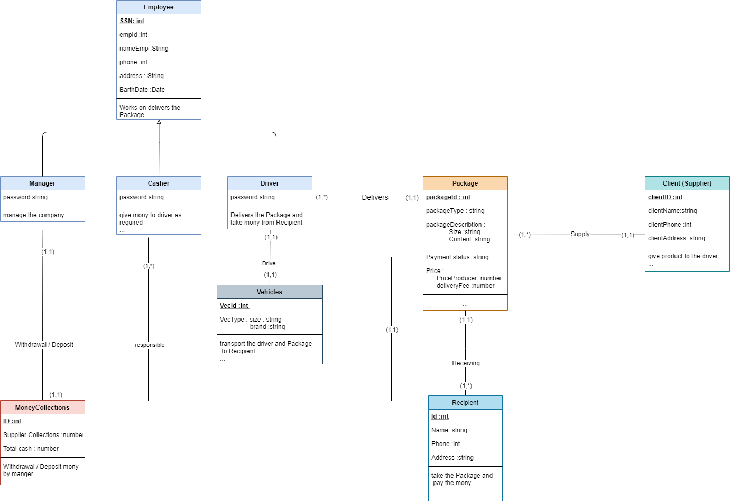

**Normalization Process:**

**All of the tables are in 3ed normal form as they have no composite columns and each of them has one primary key which is super key except the Manager table .**

**(1NF): All tables are no composite attributes in any table.**

**(2NF): Each table has only one primary key.**

**(3NF): There is no possible way to access a data table but only through its primary key.**

**Tools used in the project:**

• Jdk 15.

• Jasperreport library.

• Oracle database.

• SQL developer.

• SQL plus.

• Java.

• Drawio for UML diagram.

• NetBeans 12.2.

**project GUI:**

**Login Frame:** To make sure no one access the database except the company member .

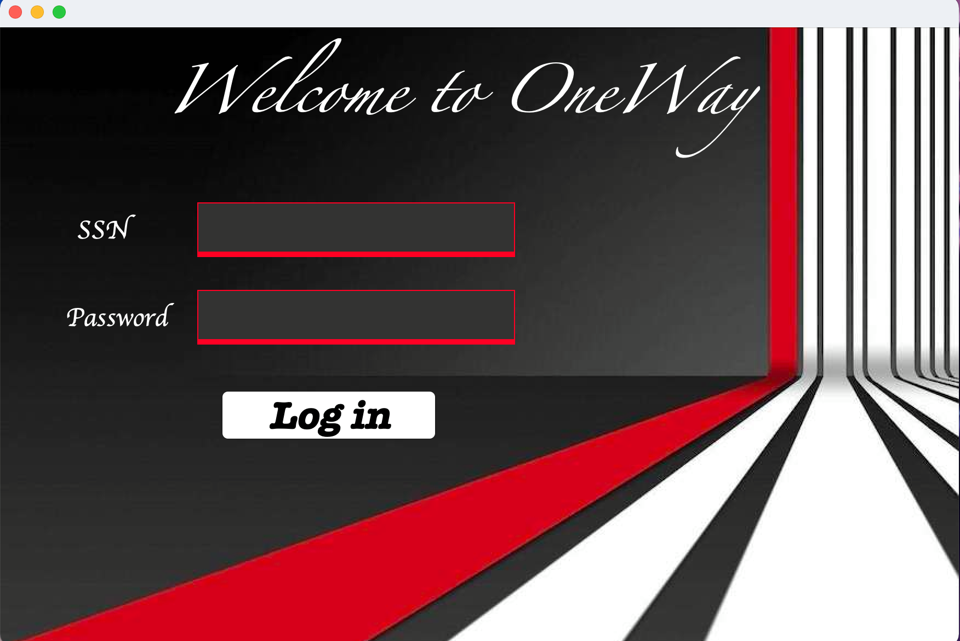

**Manager Frame:** the main frame that use to show manager information and collection mony.

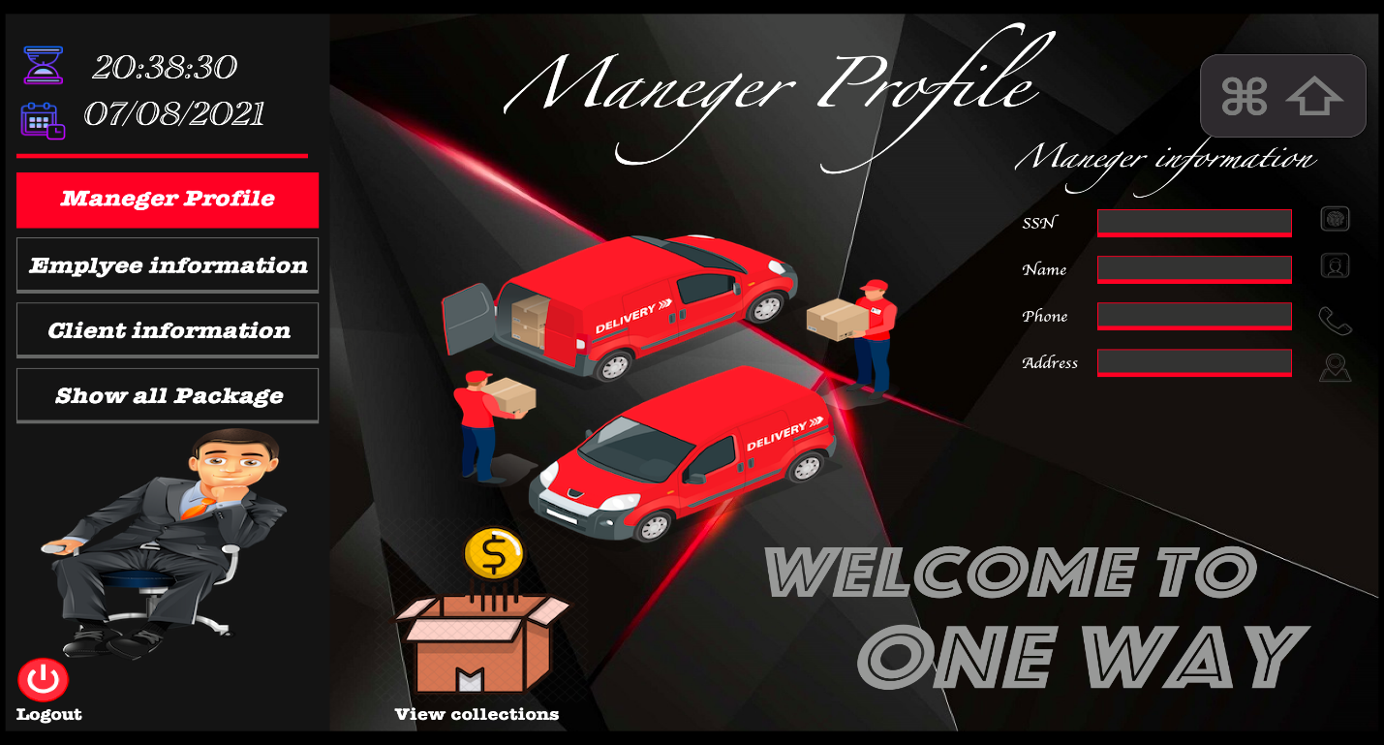

Manager Add Employee panel: we can use it add and manipulate Employee information.

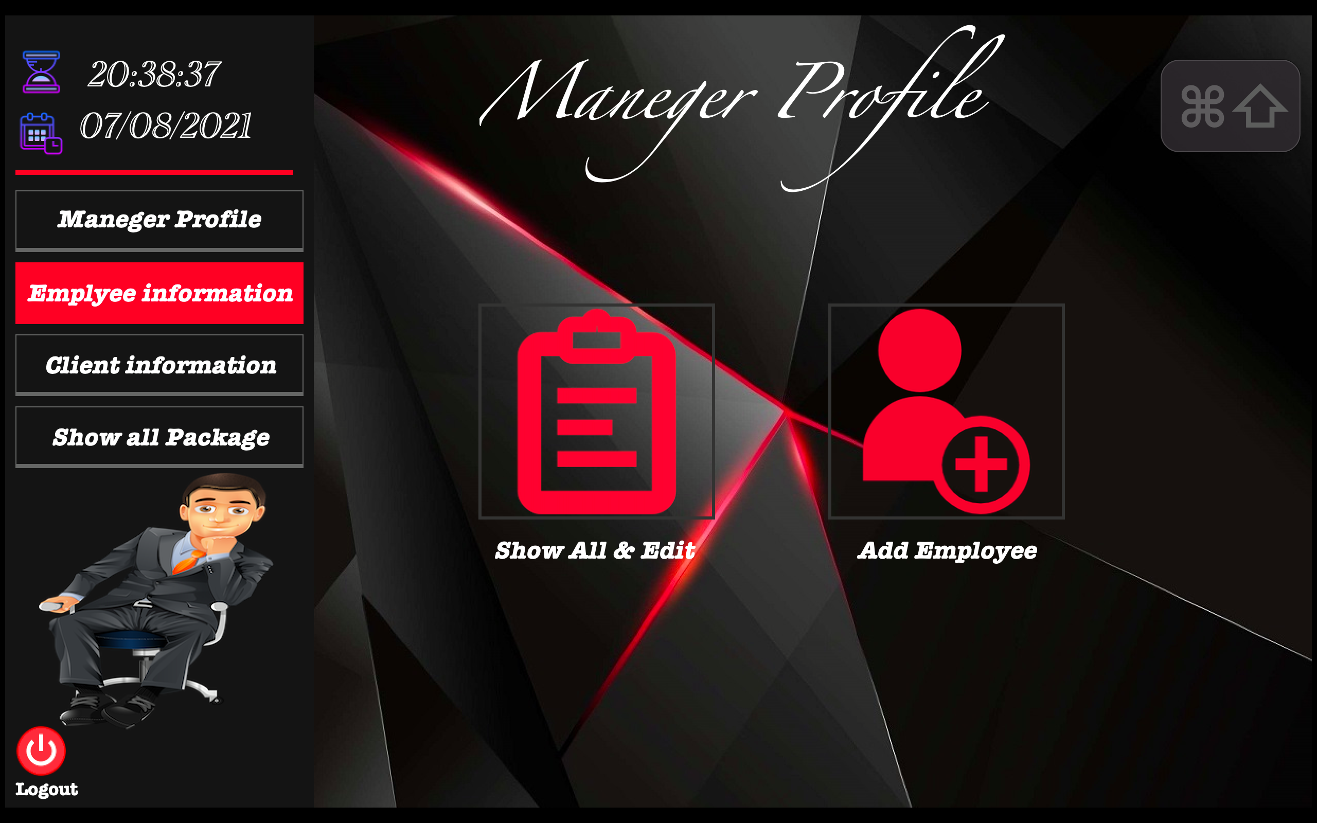

manager show all package Panel: show and search package receive it from the client .

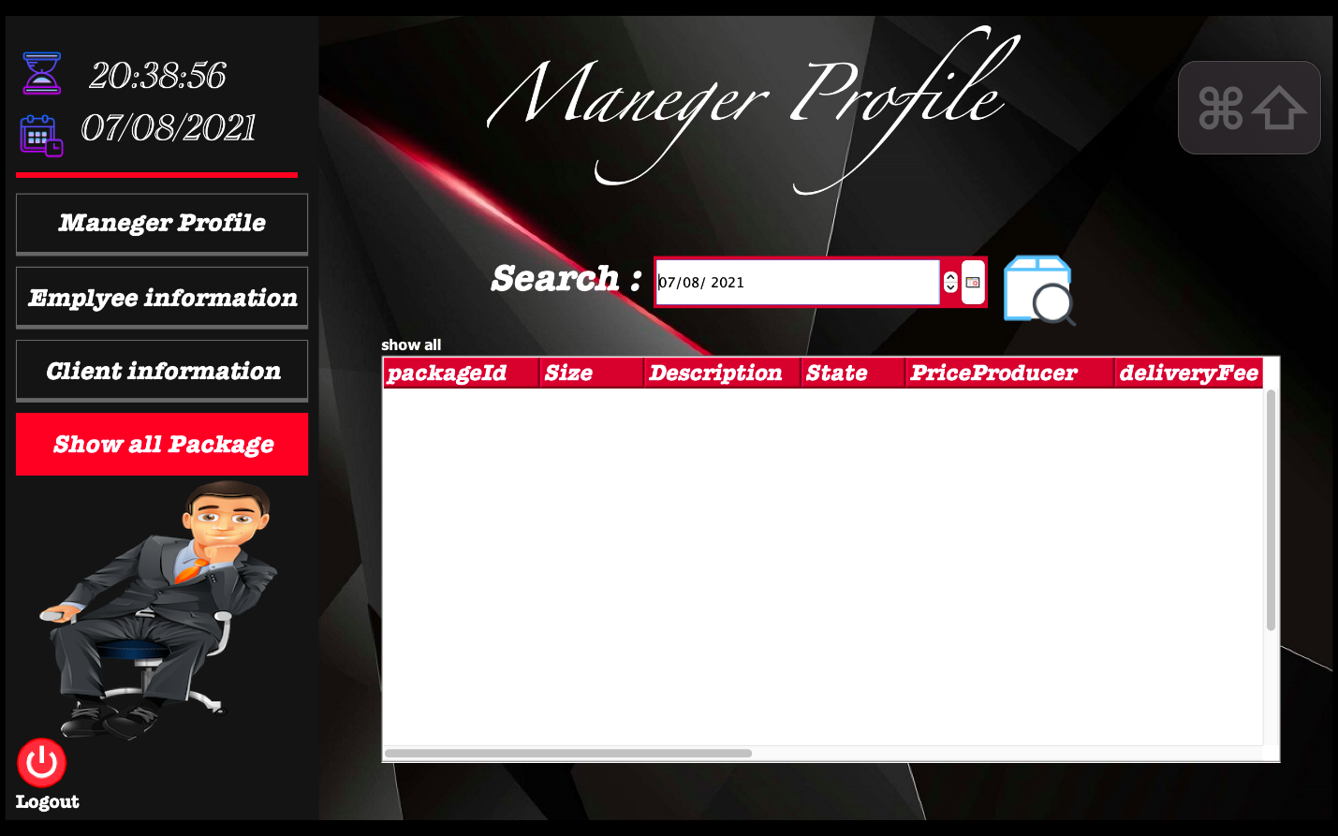

Client Profile Frame: we can use it to add Reception and package information and show the package related certain client.

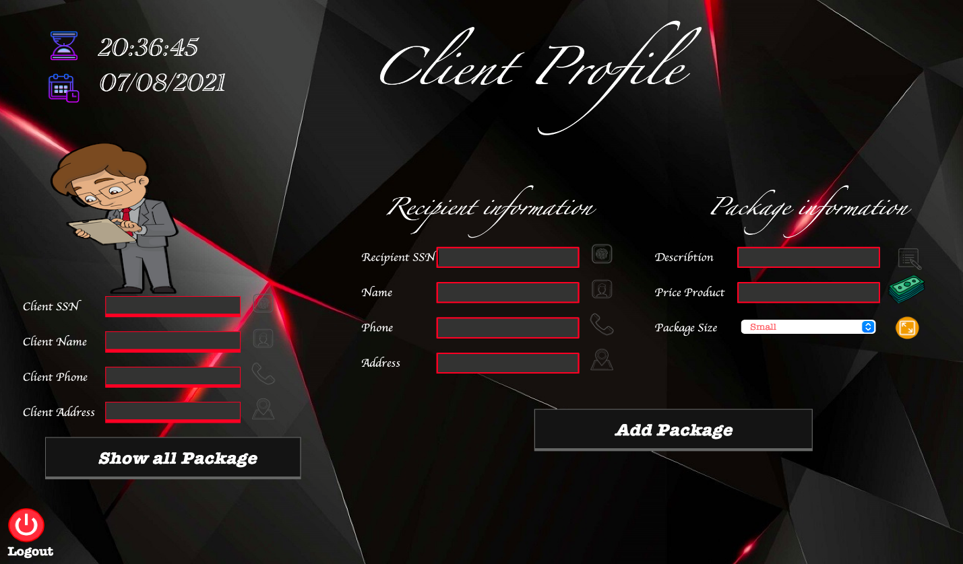

Casher Profile Frame: we can use it to Receive the package that on waiting state and show and update the package information.

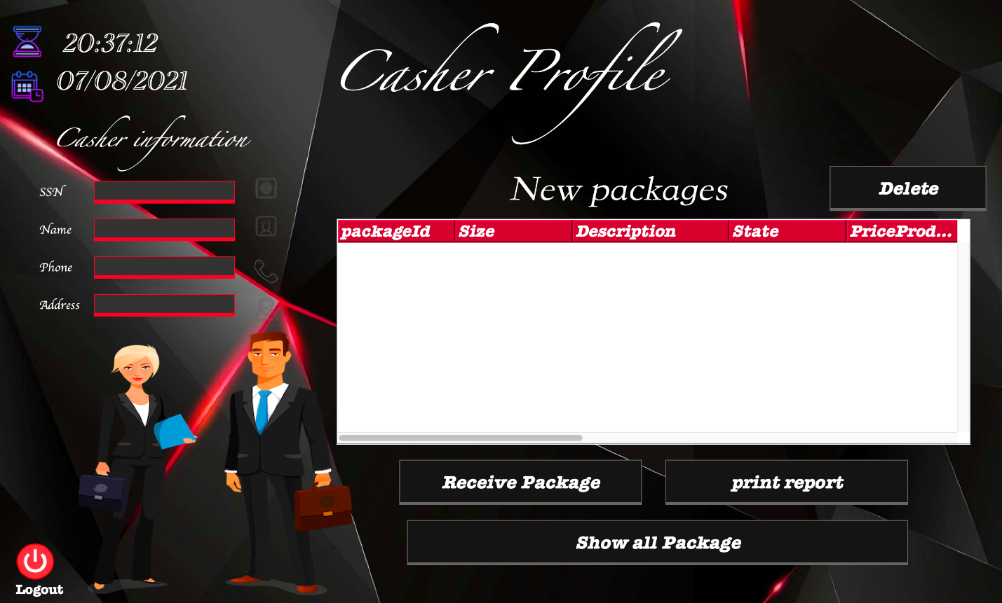

**Conclusion:**

In this project we realized how much important is the database; due to the powerful role it plays in our life especially in the 21th century when it’s about storing and retrieving lag amounts of data, and a lot of proprieties it provides that make it too easy to manipulate data through a high-level language.

**References:**

* Fundamentals of database systems, Elmasri and Navathe, latest edition.
* Database systems slides by Dr. Sufyan samara.
* w3schools.
* Stack Overflow.
* Oracle Documentations.
* YouTube.